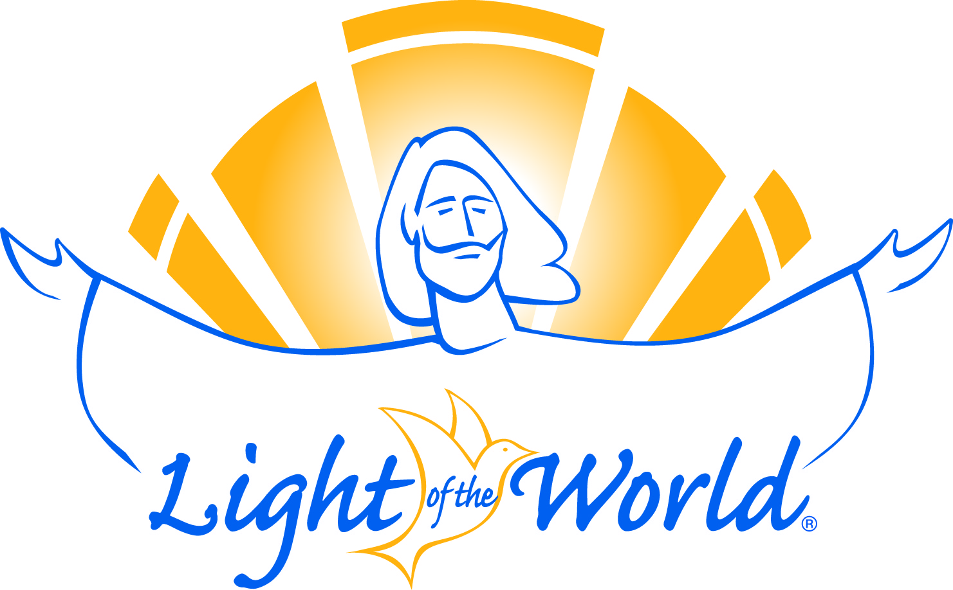

Parish Retreat in English
April 25-28, 2014

On this retreat you will personally encounter our Lord Jesus Christ, and renew your sacraments of Baptism, Confirmation and Eucharist. Each night you will return home to the comfort of your own bed. All meals, snacks and beverages will be provided for you while you are on retreat. (If you have any special needs let us know.)

We encourage you to dress comfortably and be prepared to travel between buildings for meals. You will not need to bring anything with you, but feel free to bring anything that will make you comfortable.

There will be a series of talks each day each one building upon the other. For this reason, we ask that you plan on attending the whole retreat. You won’t want to miss anything.

This is not a silent retreat. There will be time to talk and get to know your fellow parishioners making the retreat with you. Afterwards you will be invited to join a small faith-sharing community to continue to nurture and support you on your faith journey.

So that we can prepare for those attending we ask that you complete the attached registration
form and return it to the parish office as soon as possible. You will receive a confirmation letter in the mail with more information about the retreat.

“I remind you to stir into flame
the gift of God that you have."
2 Timothy 1:6
The Light of the World Retreat provides a time away from the everyday demands of life to nurture and nourish your personal relationship with God. There is no expected response, only the assurance that you are loved by God and accepted just as you are. You need only trust in God’s faithfulness.
Light of the World Retreat No. 26 Date: April 25-28, 2014

Name: ___________________________________________Phone:_______________________

Address: _________________________________City: _______________ST:____Zip:________

Marital Status: _____________________ Profession: __________________________________

Number of Children: ______ Email: ________________________________________________

Cell:_________________________ Special Needs:____________________________________

I /we have a child preparing to receive a Sacrament : ____ 1st Communion ____ Confirmation

What others have said about the Retreat:

- “I have found such inner peace. I am more aware of God in my life. My life has not been the same and I thank God every day for that!”

- “Being asked to go on the Retreat by my wife, I found a closer relationship with others at St. Rita’s, (and) a greater, or better relationship with the Lord.”

- “I think it was one of the best things that ever happened to me! I just wish more of the Church would attend.”

- “I felt uplifted and encouraged by the Spirit of God. I encourage everyone to ‘take a chance’ on finding the love of God in each one’s life! You will never be the same.”

- “The Retreat helped me to find a sense of belonging to the community of St. Rita. God has gifted me with a caring group of people to journey closer to Him.”

Retreat Schedule:
Fri. - 6:30 pm to 9:30 pm
Sat. - 8:00 am to 8:00 pm
Sun. - 8:00 am to 8:00 pm
Mon. - 6:30 pm to 9:30 pm

Mail or return retreat registration form to:
St. Rita of Cascia Evangelization Office
Attn: Mary George
750 W. Old Indian Trail, Aurora, IL 60506

For more information: 630-892-6089
mgeorge@saintritaofcascia.org

